EasyBib Set Up 2016-2017
- Go to www.easybib.com

- Click Sign-up in the upper right hand corner.

3. Choose Sign up for EasyBib Edu on the right.
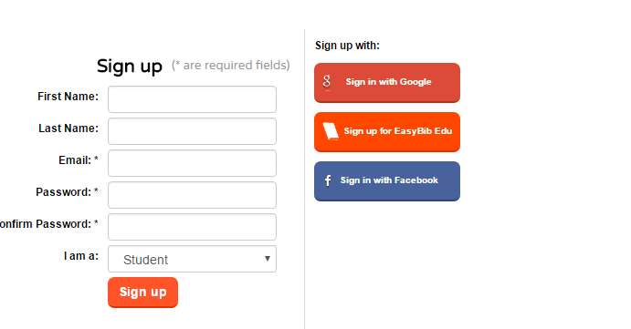
4. It will ask for an EDU code. Your teacher will have this info.
5. Enter the code. It will ask for a username and password. You will use the exact username and password that you use to log-in into the computer.
6. Click New Project.
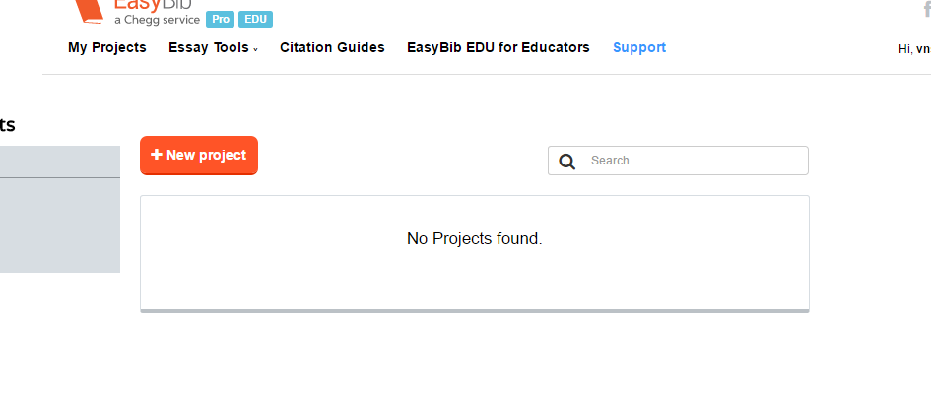
7. Project Name: List genetic disease you’re researching
Subject: life science
You do not have to explain what you’re writing about.
Default Style: select MLA8 from the drop down menu.
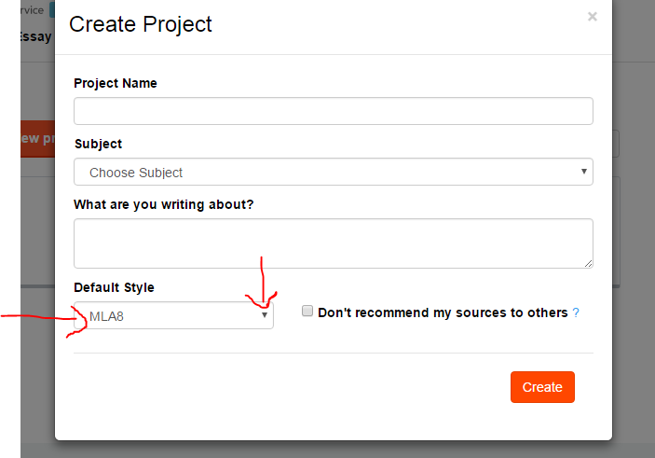

8. Once you’ve named your project, it will look similar to this. (Please do not name your project Cystic Fibrosis unless that is what you’re researching.)
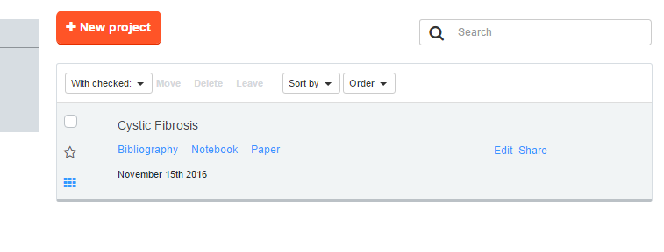
9. After you have read information and taken notes from the selected websites from our library webpage, you must cite your sources. Please see the example below.
1. Click on Bibliography.

10. Right click the URL (website address) from the site where you took notes. Right click paste once you click on Bibliography. Then, click Cite It.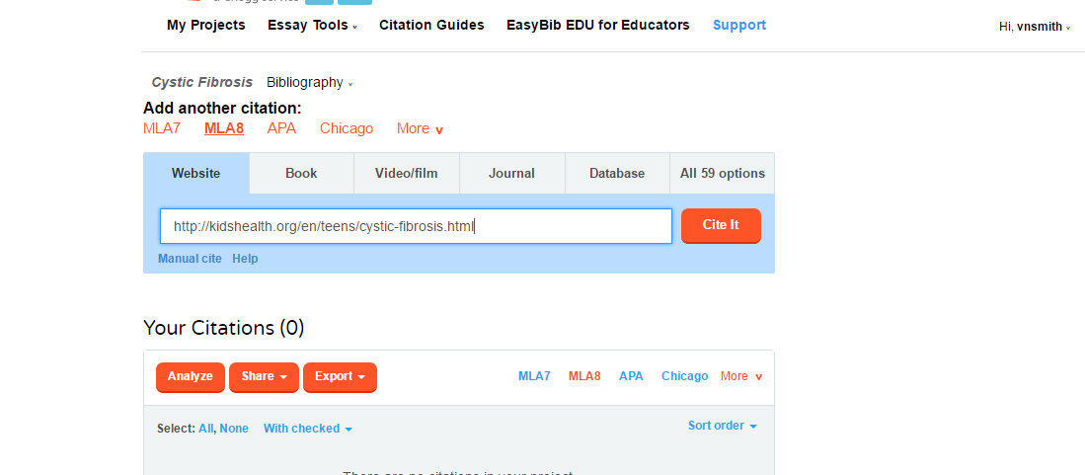
11. Next, click Cite This.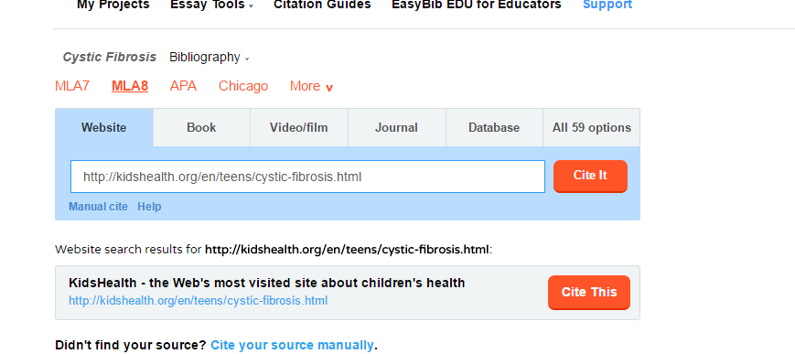

12. It will show you what’s been gathered and what they need you to identify from the website. Look for the author(s) from the site. Click Continue to final step! Note: The website I used did not have the author listed, nor did it list when it was published. Some sites will have this info. Some won’t. PLEASE double check to see if the info is listed.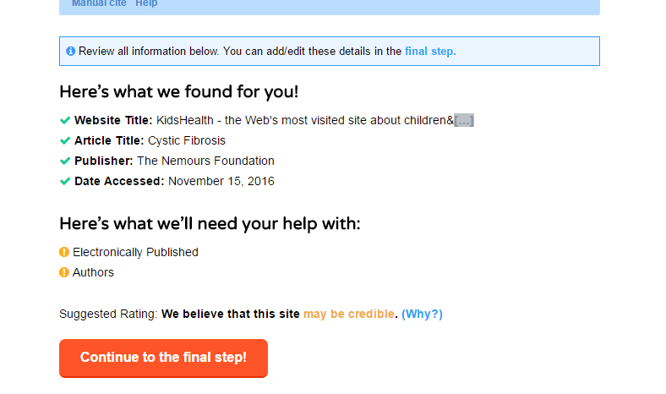
13. After you click Continue to the final step, scroll down to the bottom and select Create Citation.
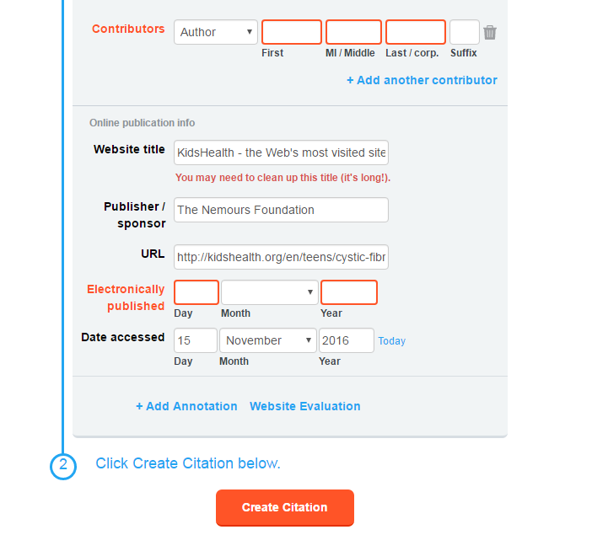

14. Your citation will look like this in MLA8 format.
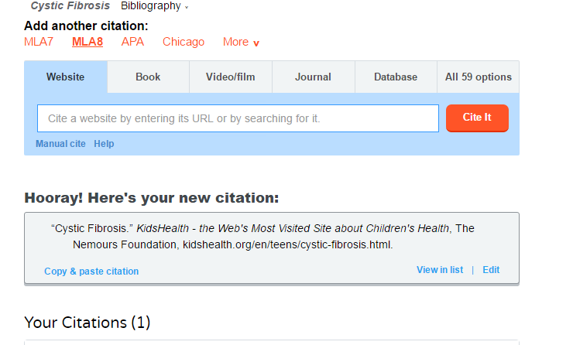
15. You will continue to do the same thing for each site you use. This way you are making sure you’re being a good digital citizen.

